Tiger Adventure: Tigers in the Wild
- With your adult partner, name and collect the Cub Scout Six Essentials you need for a hike. Tell your den leader what you would need to add to your list if it rains.
- Go for a short hike with your den or family, and carry your own gear. Show you know how to get ready for this hike.
- Do the following:
  - Listen while your leader reads the Outdoor Code. Talk about how you can be clean in your outdoor manners.
  - Listen while your leader reads the Leave No Trace Principles for Kids. Discuss why you should "Trash Your Trash."
  - Apply the Outdoor Code and Leave No Trace Principles for Kids on your Tiger den and pack outings. After one outing, share what you did to demonstrate the principles you discussed.
- While on the hike, find three different kinds of plants, animals, or signs that animals have been on the trail. List what you saw in your Tiger handbook.
- Participate in an outdoor pack meeting or pack campout campfire. Sing a song and act out a skit with your Tiger den as part of the program.
- Find two different trees and two different types of plants that grow in your area. Write their names in your Tiger handbook.
- Visit a nearby nature center, zoo, or another outside place with your family or den. Learn more about two animals, and write down two interesting things about them in your Tiger handbook.
Workbook for use with these requirements: PDF Format DOCX Format

Rationale for Adventure
Tigers will learn how to put the “outing” in Scouting with this outdoor adventure. They will start to develop an understanding of the Outdoor Ethics program as they are introduced to many skills that will be important throughout their Scouting careers.

Takeaways for Cub Scouts
- Cub Scout Six Essentials
- Plant and animal identification
- Outdoor Ethics awareness
- A Scout is obedient, thrifty [Tiger Character Compass]

NOTES TO DEN LEADER
Meeting 3 will be a den outing for a hike and visit to a nature center, zoo, or other outdoor place. In advance of the outing, the leader will need to make arrangements with the outing location and confirm the outing plan with families, including transportation and any additional items they need to bring. Make sure a tour and activity plan has been submitted, if required, and activity consent forms are distributed, signed, and collected.
You will want to record completion of requirement 5 following participation in the campfire or outdoor event. This doesn’t have to be at the same time the den completes this adventure.

Ideas for Adventure Requirements:
http://www.boyscouttrail.com/cub-scouts/tiger-in-wild-adventure.php

- Fill a daypack with the following items and have each scout come to the front and blindly pick out one item. Decide if it should be placed in the 'Useful' or 'Useless' pile of items for a day hike. Some items may depend on time of year or location. Items: water bottle, whistle, flashlight, granola bar, first aid kit, sunscreen, bus spray, sock, glove, bandanna, binoculars, rock, deck of cards, paperback book, dollar, bag of marbles, spoon, towel, Legos, toy car, can of soda, ...
- How long is a "short" hike? 2 miles per hour is a good pace. Stopping to identify plants and animals will slow you down. So, a 1-mile hike is probably long enough.
Most scouts should have a school pack or small fanny pack, but check that everyone does before your hike so no one shows up carrying gear in a plastic bag.
- While on your hike, have each scout think of a way the group is following LNT principles. Things like - stayed on the trail, left a flower, didn't run or yell when other hikers were around, picked up some litter, viewed animals from far away.
- The lead hiker should keep an eye on the dirt trail for signs of animals or they will get trampled. An early morning hike, at a nature area, on a dirt trail, before other visitors arrive, is the best bet for tracks and seeing animals. Birds can typically be viewed all day, and common ones are: robin, duck, goose, blackbird, pigeon, dove, seagull, hawk.
- Work with the Cubmaster to ensure this event gets planned since all dens have similar advancement requirements. Don't forget to practice your song and your skit a few times at a den meeting before going on stage.
- Native trees, rather than planted ornamentals, should be identified. This is easier to do while leafs are still on the trees.
- Tigers could make a game of trying to find the strangest, largest, ugliest, rarest, ... animal to learn about.

Den Meeting Ideas for Tigers In the Wild Adventure:
http://www.boyscouttrail.com/cub-scouts/tiger-in-wild-adventure.php

- The LNT Principles for Kids are listed in the back of the Tiger Handbook. Read details of the principles and implementing them atLNT.org and Outdoor Ethics.
- Use Tree ID to identify a tree from its leaf.
- Use Beneath These Tall Green Trees grace before your snack.
- Tell Tall Trees minute to the den.
- Use some Tree Activities at a den meeting.
- Perform Infantry skit for the Pack.
- Perform I Ain't Lost skit
- Tell Map and Compass minute to the den.
- Learn more about LNT from Leave No Trace Dude.
- Learn more about Hiking from Hiking Dude.
- Remember to use this Tigers In the Wild adventure as a step towards each scout's Outdoor Activity award.

Animal Tracks Book
http://www.prekinders.com/animal-tracks-book/

I made this Animal Tracks book to go in our Science Center during our Forest Animals theme this month.
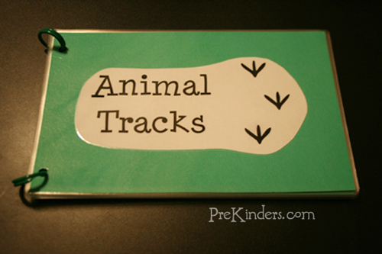
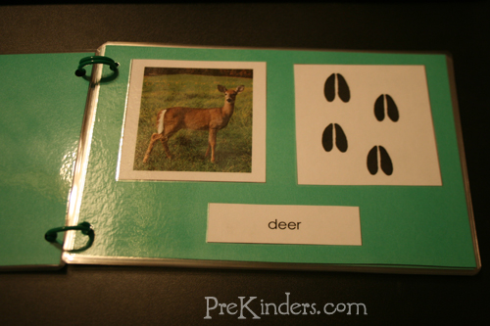
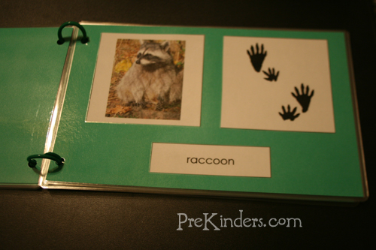
To make the book, I used a free printable from Montessori for Everyone. I printed the Animal Tracks cards and cut them apart. The pages are made with green cardstock paper, cut in half. I glued a picture of the animal and that animal’s tracks side-by-side, and one of the cards with the animal’s name below the picture. I bound the pages with chicken rings.
I also have a set of the cards printed for matching cards, and the kids can use the book as a reference to see which animal tracks match with which animal. This is one of the printables from Montessori for Everyone’s free downloads cultural materials page. Look for “Animal Tracks” under “Zoology”.

